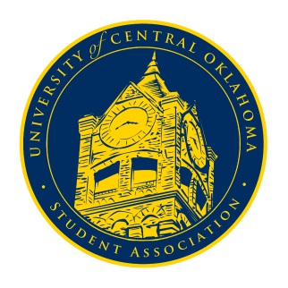
University of Central Oklahoma
Student Association

10th Meeting, Spring Session of the 24th Legislature
Ballroom C
April 12th, 2021 4:00 PM

- Call to Order
(Begins the meeting, includes opening customs and procedures)
- Pledge of Allegiance
- Roll Call
The meeting was called to order by Chairman Shannon at 4:04 pm.

- Approval of the Minutes
(This approves the secretary’s record keeping of the last meeting)
Minutes were approved.

- Special Orders
(Formalities or Proceedings not according to law or custom)
N/A

- Items to be Considered
(Business to be seen today)
N/A

- New Business
(New legislation to be sent to committee)
- Executive Board Nominations
Nominations were in order of Chair, Vice Chair, and Secretary.
Chair nominations included Joshua Chao and Tyler Owens.
Vice Chair nominations included Amariah Sheffield, Lucas Byfield, and Callie Hambrick.
Secretary nominations included Jakob Carlson, Kyia Woodson, Haley White, and Lauren Harman.
On the 19th nominees will speak for themselves for five minutes and find someone to speak on their behalf for three minutes. If you are a nominee and will not be in person for Congress, you must submit a video speaking for yourself by Friday at 12 pm. If you want to remove your name from the list, that must be done by Friday at 12 [pm. If you are not selected for a position, you can drop down to a different one if it exists.

- Student Concerns
(Open forum for any student to address concerns to the UCO Student Congress)
Senator Ibarra asked about the options for the Fall 2021 incoming and transfer students who are interested in joining UCOSA. Chairman Shannon said that they will have the opportunity to be involved in Freshman Council and run for the seats set aside for those members. If any other spots were open at the beginning of the semester, then those would also be filled.

- Announcements
(General Announcements)
Senator Griffin announced that the Unity Walk would be at 1 pm on Friday the 23rd. We would meet at the blue tent and walk around UCO’s campus.
Senator Davis announced that the Jazz Lab would be having Jazz Combos on Wednesday and Thursday at 7 pm. The Opera would be on Friday and Saturday at 7:30 pm and Sunday at 2:30 pm.
Vice Chairwoman Diaz reminded everyone that our last Congress would be on the 19th. Be thinking about the upcoming elections and also about congressional awards. She would send the awards link in the GroupMe for voting and announce winners after the elections.
Senator Lewis announced that Tuesday night there would be a Drunk Driving Awareness seminar put on by Panhellenic to honor Marissa Murrow. The event would be from 6-8 pm, and you could register through UCORE. She would send the link in the GroupMe for anyone interested.

- Adjournment
(End of meeting, must be motioned and seconded)
The meeting adjourned at 4:22 pm.

