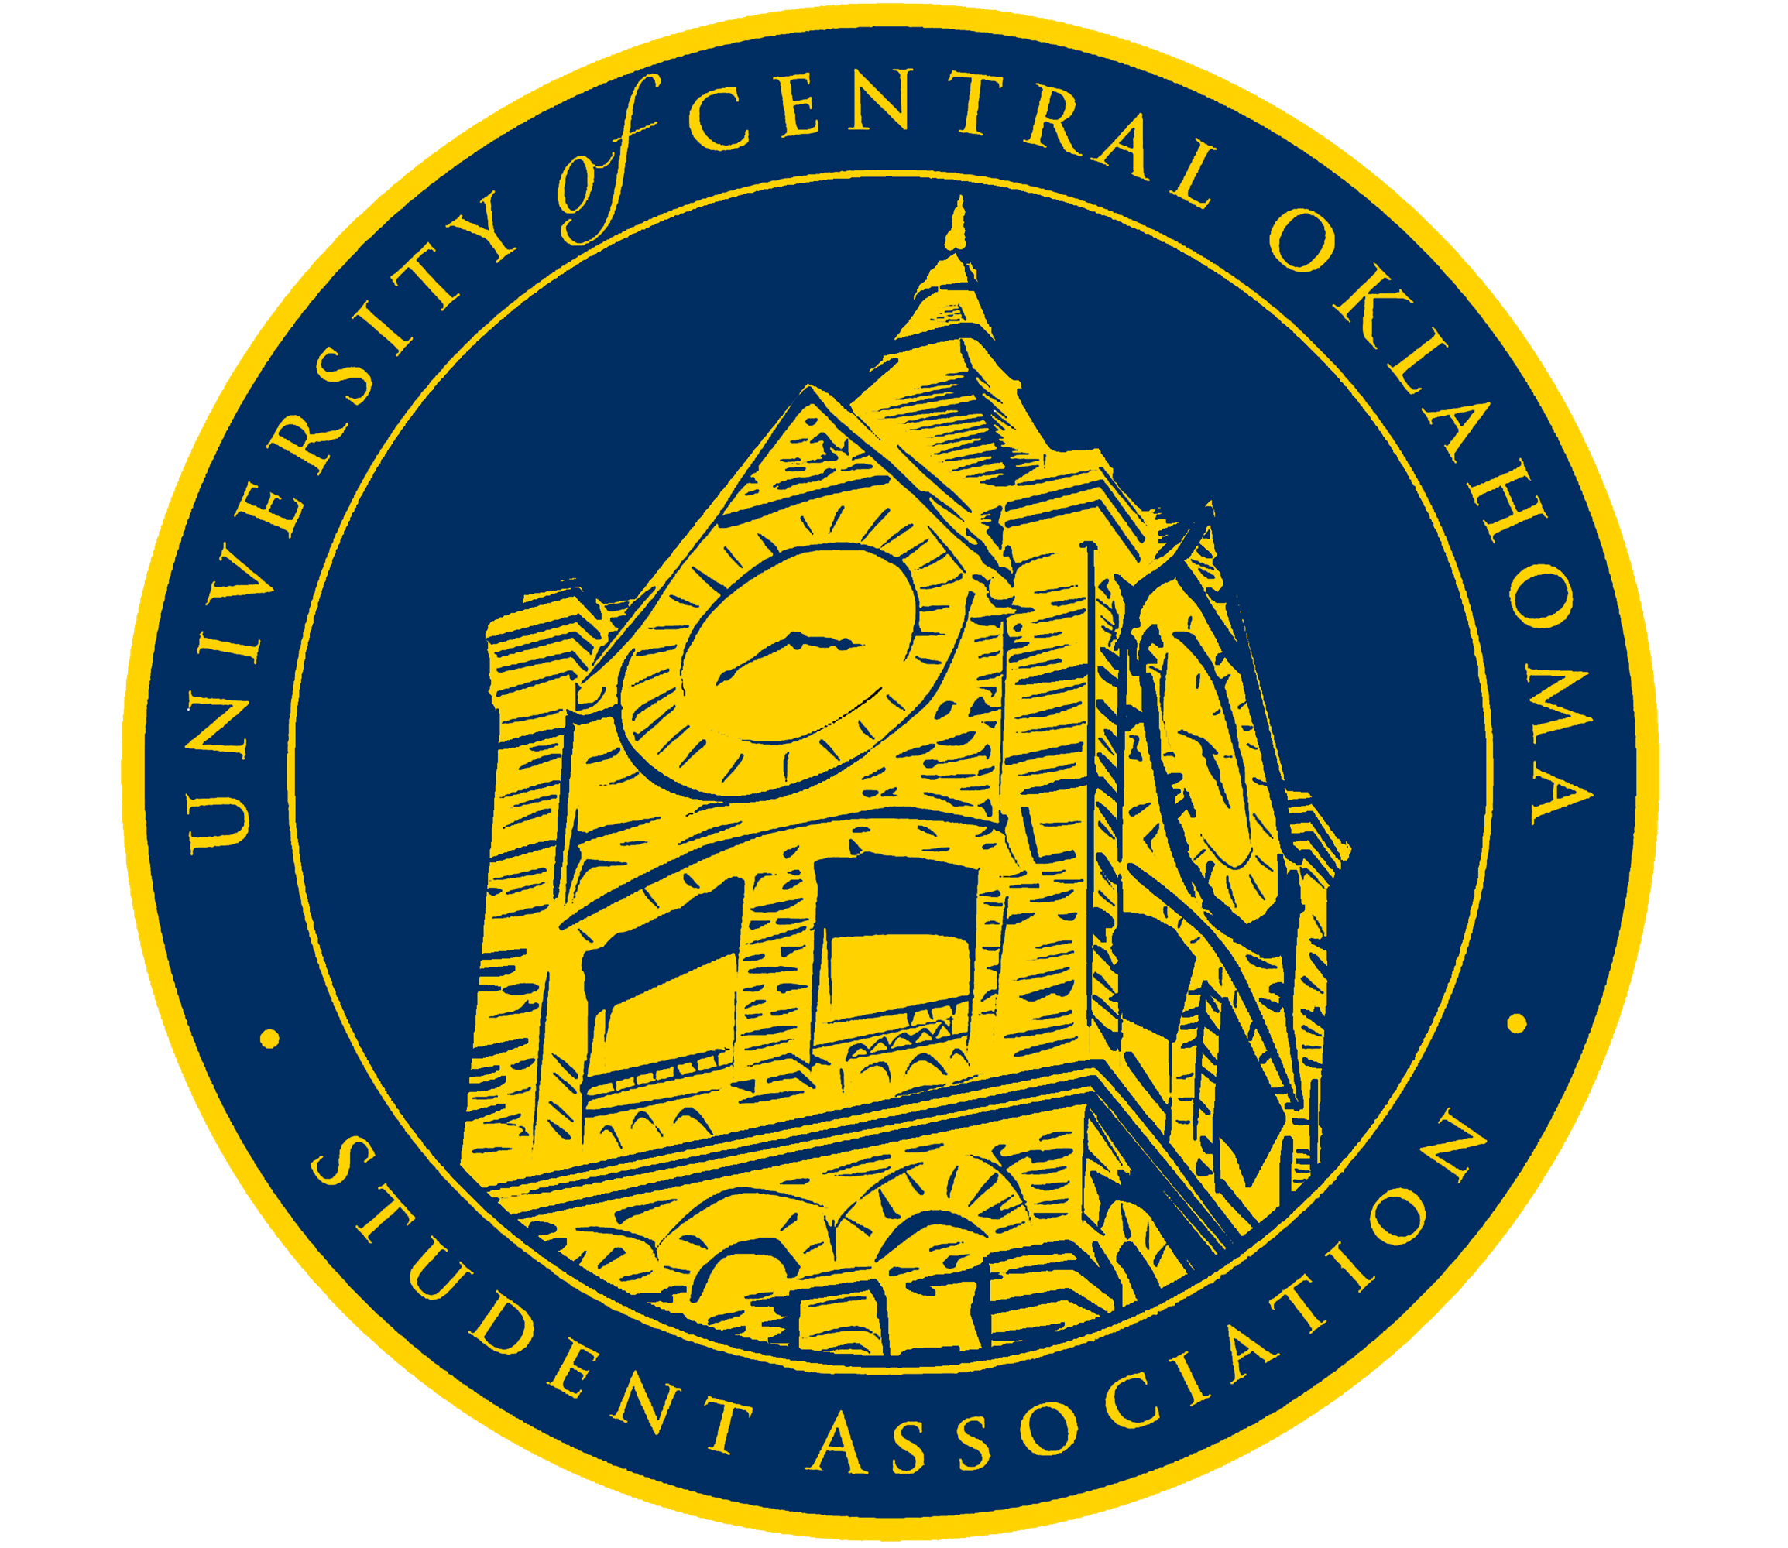 | University of Central Oklahoma Student Association  2nd Meeting, Fall Session of the 27th Legislature  NUC 421 Will Rogers Room  Monday September 11th, 2023 4:00 PM

- Call to Order
(Begins the meeting, includes opening customs and procedures)
- Pledge of Allegiance
- Roll Call

- Approval of Minutes
(This approves the secretary’s record keeping of the last meeting)

- Special Orders
(Formalities or proceedings not according to law or custom)
- Laura Butler - Assistant Vice President for Public Affairs
- Lauren Berry - Political Updates
- Jolie Barton - Hunger Action Week
- Chair Izzi Barry - Retreat Recap

- Items to be Considered
(Business to be seen today)
- CR23-100: An act of polite procedure removing senators from their congressional seats and committee assignments following their resignation.
- CR23-101: A resolution outlining the processes and procedures of appointments for vacant senator seats.

- New Business
(New legislation to be sent to committee)

- Student Concerns
(Open forum for any student to address concerns to the UCO Student Congress)

- Announcements
(General announcements)
- Chair Izzi Barry - Upcoming Dates and Obligations

- Adjournment
(End of meeting, must be motioned and seconded)

