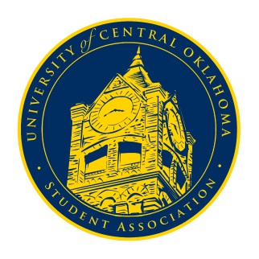
University of Central Oklahoma
Student Association

8th Meeting, Fall Session of the 24th Legislature
Virtual Meeting via Zoom
November 2nd. 2020 4:00 PM

- Call to Order
(Begins the meeting, includes opening customs and procedures)
- Pledge of Allegiance
- Roll Call
The meeting was called to order at 4:02pm.

- Approval of the Minutes
(This approves the secretary’s record keeping of the last meeting)
- Special Orders
(Formalities or Proceedings not according to law or custom)

- Items to be Considered
(Business to be seen today)

- New Business
(New legislation to be sent to committee)

- Student Concerns
(Open forum for any student to address concerns to the UCO Student Congress)
Vice-Chair Turner brought up concerns over the new enrollment procedures and suggested that a guide email should be sent out to students. Chairman Shannon announced that someone from the enrollment office may be invited to speak to congress about the issue. Senator Chao asked if Ways and Means was able to get the requested funds budget approved. Senator Byfield and Chairman Shannon informed that the application had not yet been approved because of the snow week, but that those meetings to approve them will be rescheduled and to expect it by the coming weekend. Finally, Senator Grim brought up student demands for the reimplementation of the Pass/No Pass option. Senator Shannon informed that VP Chris Lynch had been informed about the issue and reminded us that, ultimately, the decision was up to the State Board of Reagents. Senator Owens informed that OSGA was also drafting legislation over the issue.

- Announcements
(General Announcements)
Senator Owens announced that OSGA’s Fall Congress will be held Friday and Saturday, November 6th and 7th. Senator Hambrick thanked senators for being flexible in getting their headshots taken and that they are looking into different options for those who couldn’t have one taken. Senator Farias announced several events from the Office of Diversity and Inclusion including Native American Heritage Month, the enrollment challenge, and MLK oratory competition deadlines. More information can be found on ODI’s social media. Senator Giannina Albinez-Chavez announced that International Student Council’s Around the Globe snack event is in Friday, November 6th from 3-6 in the Liberal Arts building. Cole Stanley announced that there will be programming on campus throughout the week in honor of Election Day. Finally. Senator Shannon reminded congress that despite the passing of CR20-01, professors can still enforce attendance.

- Adjournment
(End of meeting, must be motioned and seconded)
The meeting was adjourned at 4:24pm. The next meeting will be held on Monday, November 9th, 2020 at 4pm via zoom.

