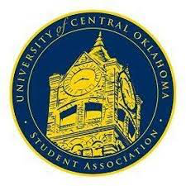
University of Central Oklahoma
Student Association

13th Meeting, Fall Session of the 26th Legislature
Heritage Room
November 28th, 2022, 4:00 PM

- Call to Order
(Begins the meeting, includes opening customs and procedures)
- Pledge of Allegiance
- Roll Call
The meeting was called to order by Chairman Hammond at 4:04 pm.

- Approval of the Minutes
(This approves the secretary’s record keeping of the last meeting)
Last week's minutes were approved.

- Special Orders
(Formalities or Proceedings not according to law or custom)
Vote of No Confidence

- Items to be Considered
- New Business
(New legislation to be sent to committee)

- Student Concerns
(Open forum for any student to address concerns to the UCO Student Congress)

- Announcements
(General Announcements)

Senator Davis gave an update about Campus Developing safety walk addressing any campus concerns.
Senator Owens spoke about the OSGA legislation packet which includes all legislation passed during the fall session
Senator Briggs spoke about the Housing meeting where they addressed the issues with recycling. They spoke about logistic issues with recycling in housing.
Senator Carlson spoke about sitting in on the Annual budget hearing encouraging senators to sit in
Lauren Berry spoke about different house bills that are being presented in the Oklahoma legislature in the upcoming weeks.
Senator James spoke about WinterGlow Happening on Dec 2nd.
Vice Chair Howry spoke about the international townhall that is going on after congress.
Senator Lewis wished Chairwomen Hammond safe travel overseeing into the spring semester.
- Adjournment
(End of meeting, must be motioned and seconded)
The meeting was adjourned at 5:07 pm.

