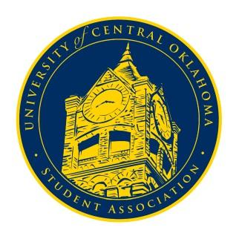
University of Central Oklahoma
Student Association

6th Meeting, Spring Session of the 26th Legislature
Nigh University Center, Will Rogers Room
March 6th, 2023, 4:00 PM

- Call to Order
(Begins the meeting, includes opening customs and procedures)
- Pledge of Allegiance
- Roll Call

- Approval of the Minutes
(This approves the secretary’s record keeping of the last meeting)

- Special Orders
(Formalities or Proceedings not according to law or custom)
- Lauren Berry Director of Political Affairs
- Izabel Barry A.R.T. Chair

- Items to be Considered
(Business to be seen today)
CFR22-206
CR22-207
CR22-208

- New Business
(New legislation to be sent to committee)

- Student Concerns
(Open forum for any student to address concerns to the UCO Student Congress)

- Announcements
(General Announcements)

- Adjournment
(End of meeting, must be motioned and seconded)

Important Dates:
March 21st – Election Day
April 24th – Campus Elections

