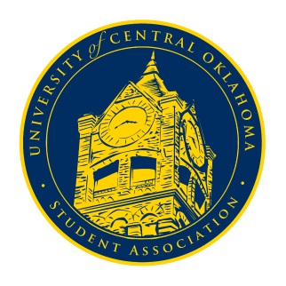
University of Central Oklahoma
Student Association

10th Meeting, Fall Session of the 24th Legislature
Virtual Meeting via Zoom
November 16th. 2020 4:00 PM

- Call to Order
(Begins the meeting, includes opening customs and procedures)
- Pledge of Allegiance
- Roll Call
The meeting was called to order at 4:02pm

- Approval of the Minutes
(This approves the secretary’s record keeping of the last meeting)
According to a special order put in place by the Open Meetings Act, no decision making meetings shall be held online past November 15thand as a result no quorum was established, minutes were unable to be approved, no special orders could be presented, and no motions could be carried.
- Special Orders
(Formalities or Proceedings not according to law or custom)

- Items to be Considered
(Business to be seen today)

- New Business
(New legislation to be sent to committee)

- Student Concerns
(Open forum for any student to address concerns to the UCO Student Congress)
Senator Kassidy Ferrell brought up soliciting concerns in dining locations on campus due to recent instances of patrons being “harassed” in attempt to get donations for organizations like Bronchothon. The issue was sent to Campus Development so that the concern may be brought to housing director Scott Monetti. CD Chairman Josh Chao asked, on behalf of the Students for Sustainability organization, that UCOSA help to publicize their compost bin under the Nigh’s outdoor staircase. The issue was sent to Public Relations.

- Announcements
(General Announcements)
Senator Nathan Ferrell announced that Cheer and Dance would be hosting an informational meeting on Thursday, November 19th, at 7pm in order to inform groups about changes being made to the program and promote sign ups. Diversity and Inclusion Chairman Griffin announced that she would be sending out a survey by the Healthy Campus Initiative and requested that everyone fill it out. DI Vice-Chairman Beyonce Hammond announced that Black Student Association’s Fatsgiving celebration would be held on Tuesday, November 17th in the Nigh Ballrooms from 6pm-8pm. Finally, Chairman Shannon announced that the last congressional session of the semester would held in person on Monday, November 23rd at 4pm in the Constitution Hall.

- Adjournment
(End of meeting, must be motioned and seconded)
The meeting was adjourned at 4:18pm. The next meeting will be held on Monday, November 23rd, at 4pm in Constitution Hall.

