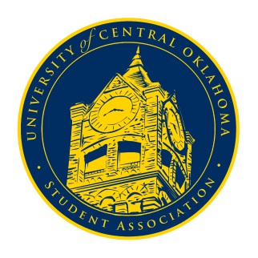
University of Central Oklahoma
Student Association

1st Meeting, Spring Session of the 24th Legislature
Virtual Meeting via Zoom
January 25th, 2021 4:00 PM

*Due to the end of the Oklahoma Open Meetings Act exception (2020) allowing for online meetings, no formal congressional meeting procedures may take place*

- Begin Meeting
(No formal call to order to roll taking)
Chairman De Shannon began the meeting at 4:02pm

- Student Concerns
(Open forum for any student to address concerns to the UCO Student Congress)
No student concerns were brought to the floor

- Announcements
(General Announcements)
Chairman Shannon announced that several senator positions were open and that upperclassmen student may apply for the open positions. Applications for new senators would remain open until February 3rd at 5:00pm. Chairman Shannon also announced that former Vice-Chairwoman Hannah Turner has stepped down and the Secretary DeLauren Diaz would be promoted the position of Vice-Chair. The promotion then subsequently opened up the position of secretary for any senators to apply. The application will remain open until February 1st at 11:59pm and that all questions can be directed to Shannon or Diaz.

- Adjournment
(End of meeting, must be motioned and seconded)
The meeting was adjourned at 4:17pm. The next will take place on Monday, February 1st, 2021 via Zoom.

