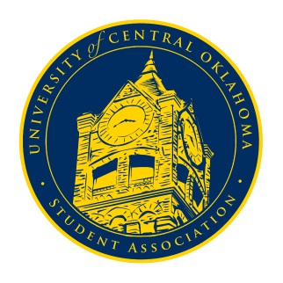
University of Central Oklahoma
Student Association

4th Meeting, Fall Session of the 24th Legislature
Virtual Meeting via Zoom
September 28th, 2020 4:00 PM

- Call to Order
(Begins the meeting, includes opening customs and procedures)
- Pledge of Allegiance
- Roll Call
The meeting was called to order at 4:32pm

- Approval of the Minutes
(This approves the secretary’s record keeping of the last meeting)
- Special Orders
(Formalities or Proceedings not according to law or custom)
Committee Clarification - All committees have been formulated so senators must be responding to their chairmen in the GroupMe to get meeting times finalized.

- Items to be Considered
(Business to be seen today)
No items to be considered

- New Business
(New legislation to be sent to committee)
No new business

- Student Concerns
(Open forum for any student to address concerns to the UCO Student Congress)
The only student concern that was brought up by Senator Chao over the issue of spring break being removed from the academic calendar. It was clarified by Senator Nathan Ferrell that this was done out of travel concerns, but that a lack of a break in the semester would cause a drop on student morale, especially at the six week point, it was urged that we inform other students why the decision was made when possible. Vice chair Turner informed that some students were trying to get media attention over the issue. Advisor Cole Stanley advised that if UCOSA, or any students, should be clear and consistent in their demands and that they should be presented sooner rather than later, through UCOSA’s channels. Several possible solutions were brought up by Senator Grim and Senator Loveless in order to allow students the opportunity to still experience breaks throughout the semester.

- Announcements
(General Announcements)
Senator Clarke brought up that Homecoming week was this week and that students should vote for royalty candidates. Chairman Shannon announced that Bronchothon has several executive positions open and that anyone who would like to apply can do so on UCORE. Secretary Diaz announced that the RHA town hall would be on Wednesday, October 7th from 4pm to 5pm and that all senators, especially on-campus senators, so that we can represent UCOSA and listen to student concerns. Secretary Diaz announced that Congress on October 19th will be in person and while there will be a virtual option, is it important that everyone tries to attend in person because we will be having several guest speakers. The attire will be business casual. Secretary Diaz announced that UCO’s Speech and Debate team will be hosting virtual debate watch parties for every presidential debate. They will all start at 8pm and the zoom link can be found on UCORE. Senator Megan Watkins announced that UCOLA facilitator applications close on Thursday, October 1st, at 11:59pm. The application can be found on Leadership Central’s UCORE page. Finally, Senator Nathan Ferrell announced that Cheer and Dance was still scheduled to happen in spring 2021 with several COVID restrictions in place for safety and that several rules and regulations were being changes to make the event more inclusive. An interest form will be sent out to see which organizations are interested in participating but completing this form does not serve as an agreement for obligation to participate.

- Adjournment
(End of meeting, must be motioned and seconded)
The meeting was adjourned at 4:32pm. The next meeting will be held on Monday, October 5th, at 4pm via zoom.

