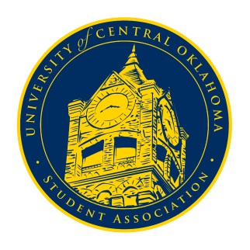
University of Central Oklahoma
Student Association

3rd Meeting, Fall Session of the 24th Legislature
Virtual Meeting via Zoom
September 21st, 2020 4:00 PM

- Call to Order
(Begins the meeting, includes opening customs and procedures)
- Pledge of Allegiance
- Roll Call
The meeting was called to order at 4:02pm

- Approval of the Minutes
(This approves the secretary’s record keeping of the last meeting)
- Special Orders
(Formalities or Proceedings not according to law or custom)
- Swearing in of Freshman Senators by Chairman Shannon
Eight newly elected freshman senators were sworn into their positions by Chairman De Shannon

- Items to be Considered
(Business to be seen today)

- New Business
(New legislation to be sent to committee)

- Student Concerns
(Open forum for any student to address concerns to the UCO Student Congress)
Senator Lewis brought up a concern over some students having to pay for required, proctored, tests despite students who take virtual classes not having to do the same. Advisor Cole Stanley stated that professors have been advised to administer less tests for this reason, but UCOSA will into it further. Senator Grim brought up concerns from nursing students over some faculty, staff, and students easing up on following COVID-19 restrictions. Advisor Cole Stanley determined that we would need more specific information in order to act on the issue. Senator Smith brought up her concern over some lecture and lab professors not teaching at the same pace as their counterparts, causing a lapse in curriculum. It was determined that Academic Affairs will look into it further upon formation. Senator Lenochan asked for clarification on whether it was mandatory or up to the professor’s discretion to have virtual or in-person office hours. Senator Clark stated that, at least for math and science professors, virtual office hours are mandatory. The final student concern was brought up by vice chair Turner over the inadequate parking, lighting, parking and safety measures for students living in the Quad. Senator Howry brought up that several Quad RAs had met with housing director Scott Monetti and some progress had been made towards resolving these issues and that further issues could be brought up to Quad RAs, including senator Howry, but the campus development committee was urged to stay up to date on the status of that progress

- Announcements
(General Announcements)
Secretary Diaz made the announcement of the new chairmen and vice chairmen of each of the six committees and stated that all committees will be finalized by Wednesday evening, September 23rd. Senator Smith announced she is doing a survey over healthcare among students and that those interested in participating should contact her. Senator Owens brought up that, as vice chair of academic affairs, he would be looking into several of the student concerns further. Senator Callie Hambrick announced that the applications for UCOLA facilitators close on October 1st and that the position offers service hours. Those with further questions were to contact her, Megan Watkins, Jose Ibarra, Nathan Ferrel, or anyone else who served/worked with UCOLA. She also announced that little event would be taking place on October 24th. Team leader applications are open until October 2nd, volunteer applications are open until October 9th, and those with further questions may contact her or team leader coordinator Mich Hambrick. The final announcement, made by Chairman Shannon, was to inform about pre-law society’s intro to LSAT event led by Maddie Farris, taking place virtually on Wednesday, September 23rd.

- Adjournment
(End of meeting, must be motioned and seconded)
The meeting was adjourned at 4:29pm. The next meeting will take place on Monday, September 28th, 2020, via zoom.

