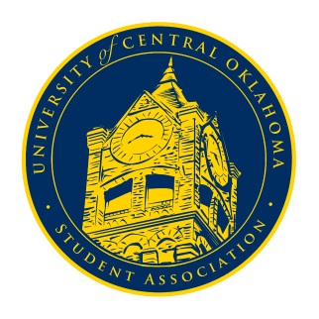
University of Central Oklahoma
Student Association

5th Meeting, Spring Session of the 24th Legislature
Ballroom C
March 8st, 2021 4:00 PM

- Call to Order
(Begins the meeting, includes opening customs and procedures)
- Pledge of Allegiance
- Roll Call
The meeting was called to order at 4:05 pm by Chairman Shannon.

- Approval of the Minutes
(This approves the secretary’s record keeping of the last meeting)
The minutes were approved.

- Special Orders
(Formalities or Proceedings not according to law or custom)
N/A

- Items to be Considered
(Business to be seen today)
N/A

- New Business
(New legislation to be sent to committee)
Senator Chao let us know that he contacted Scott Monetti about possibly coming to Congress on March 22nd along with another representative.

- Student Concerns
(Open forum for any student to address concerns to the UCO Student Congress)
Senator Grim let everyone know that there have been repetitive wasp infestations in the Commons and had heard about this issue from multiple students throughout the last couple of weeks.
Senator Chao added that he emailed Scott Monetti about the issue last week, and Scott said it was resolved; Senator Grim said that the issue persisted.
Senator Hambrick brought up the problem of the “What Not to Wear” signs in the Wellness only portraying female clothing issues to see if we could look into that.

- Announcements
(General Announcements)
Senator Ferrell announced that Cheer and Dance would be on April 22nd and 23rd and encouraged organizations to participate. He said they are taking all the necessary precautions for our safety so everyone can experience a fun event.
Senator Loveless announced that the Student Alliance for Equality would be having a student panel the next day on Zoom and announced their executive board was taking applications now.
Senator Howry announced that the Public Relations committee would be starting Senator Saturdays as senator shout-outs. They would be doing the PR committee shout-outs first to provide an example of what those would entail. Senator Howry also announced that the BCM would be having a sunset picnic that Thursday at 9 pm at the BCM building put on by the women’s ministry.
Senator Griffin announced that Pocketbook Monologues would be on Wednesday at 7 pm in Constitution Hall put on by the Women’s Outreach Center and the Black Student Association.
Senator Owens announced that he was chairing the Election Committee this year and that the committee voted to extend filing for President and Vice President to Sunday the 14th at 11:59 pm. They would be proposing legislation at the next Congress and would get with the PR committee to promote election details.
Chairman Shannon announced that Neshawn and the ODI were looking for student volunteers to be part of the Inclusive Community Committee; he would invite Neshawn to Congress to talk about this.
He also said that the councils under UCOSA that receive money from us would be coming to the next congressional session to explain what they use the money for and present why they need it. He explained that our statutes have rules regarding how much money they can get, and the statutes also require the UCOSA executive council to review their budgets every three years for any changes. At the next Congress we would be voting on if their budgets should change or stay the same.

- Adjournment
(End of meeting, must be motioned and seconded)
The meeting was adjourned at 4:24 pm.

