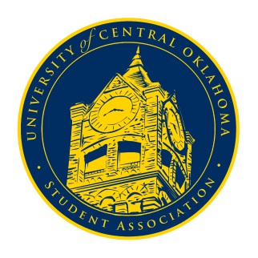
University of Central Oklahoma
Student Association

3rd Meeting, Spring Session of the 24th Legislature
Ballroom C
February 22nd, 2021 4:00 PM

- Call to Order
(Begins the meeting, includes opening customs and procedures)
- Pledge of Allegiance
- Roll Call
The meeting was called to order at 4:07 pm by Vice Chairwoman DeLauren Diaz.

- Approval of the Minutes
(This approves the secretary’s record keeping of the last meeting)
- Approval of Minutes from the past 3 meetings
  - November 23rd minutes
  - January 25th minutes
  - February 1st minutes
All three minutes were approved.
- Special Orders
(Formalities or Proceedings not according to law or custom)
- Swearing in of the new Congressional Secretary, Callie Hambrick
- Swearing in of the new Senators
- Callie Hambrick was sworn in as Secretary.
- Keely Dooley, Bonnie King, and Trinity Davis were sworn in as Senators.

- Items to be Considered
(Business to be seen today)
There were no new items to be considered.

- New Business
(New legislation to be sent to committee)
There was no new business to be considered.

- Student Concerns
(Open forum for any student to address concerns to the UCO Student Congress)
There were no student concerns.

- Announcements
(General Announcements)
- Vice Chairwoman DeLauren Diaz encouraged everyone to attend Congress in person
- Senator Griffin announced the Pocketbook monologue competition next Thursday at 5 pm
- Senator Smith said she is trying to get healthcare for international students; she needs help from those who are interested, so please contact her if you would like to help
- Senator Farias announced Bronchothon would be having a giveback night the next evening from 5:30 to 10 pm
- Chairman De Shannon announced that the OMA has been pushed through to allow us to meet and vote over Zoom if necessary

- Adjournment
(End of meeting, must be motioned and seconded)
The meeting was adjourned at 4:17 pm, and the next meeting will be March 1st at 4:00 pm.

