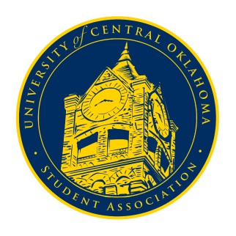
University of Central Oklahoma
Student Association

2nd Meeting, Fall Session of the 24th Legislature
Virtual Meeting via Zoom
September 14th, 2020 4:00 PM

- Call to Order
(Begins the meeting, includes opening customs and procedures)
- Pledge of Allegiance
- Roll Call

- Approval of the Minutes
(This approves the secretary’s record keeping of the last meeting)
- Special Orders
(Formalities or Proceedings not according to law or custom)
No special orders were brought to the floor.

- Items to be Considered
(Business to be seen today)
There were no items to be considered.

- New Business
(New legislation to be sent to committee)
There was no new business to be addressed.

- Student Concerns
(Open forum for any student to address concerns to the UCO Student Congress)
There were several student concerns brought to the floor. Senator Arvizo brought up student complaints about the food at Ayers Kitchen not being good and that some menu items were taken off the menu at 1890. Arvizo sent out an opinion survey about the issue later in the week. Senator Watkins asked if we could look into having Election Day turned into a campus holiday. UCOSA exec would look further into the issue. Senator Owens brought up the issue that there were several transfer students wanted to run for UCOSA seats within Freshman Assembly. After some discussion over the bylaws it was determined that only freshman were allowed to run for Freshman Assembly seats during this term. Senator Bostic brought up that the bookstore hours were not inclusive for students who attend school at night and while the issue had been temporarily resolved, it should be looked into for future purposes. It was determined that UCOSA exec will look further into the issue. Senator Nathan Ferrell brought up that there is not enough space in the library for students to study at night with the temporary closure of the 3rd and 4th floor. It was determined that UCOSA exec will look into it further. Cabinet member Han Seth Lu brought up that students were still documenting themselves without masks. It was determined that UCOSA exec would look into it further. Senator Arvizo brought up that some students had still not received financial aid. It was determined by Senator Nathan Ferrell and advisor Cole Stanley that the office is really backed up at the moment and the any issues could be resolved by booking a financial aid appointment. Senator Sheffield asked for follow up on the previous week’s concern over the limited entrances in the Qaud (see minutes from August 31st). It was determined that both student body Vice President Christian Coleman and Quad director Marcus Titterington would be meeting separately twith housing to discuss the issue, and that further complaints or concerns may be brought to them or senator Howry.

- Announcements
(General Announcements)
The only announcement brought to the floor was by Senator Farias stating that Diversity Round Table will be hosting a demonstration over racial injustice at the Blue Tent on September 23rd at 10am. Masks and social distancing are required.

- Adjournment
(End of meeting, must be motioned and seconded)
The meeting was adjourned at 4:27pm. The next meeting will be held on Monday, September 21st via zoom.

