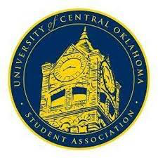
University of Central Oklahoma
Student Association

9th Meeting, Spring Session of the 26th Legislature
Will Rogers
April 3rd , 2023, 4:00 PM

- Call to Order
(Begins the meeting, includes opening customs and procedures)
- Pledge of Allegiance
- Roll Call
The meeting was called to order by Chairman Howry at 4:05 pm

- Approval of the Minutes
(This approves the secretary’s record keeping of the last meeting)
Last week's minutes were approved.

- Special Orders
(Formalities or Proceedings not according to law or custom)
Art Committee- Gave committee updates and what the committee’s future projects for the rest of the semester.

- Items to be Considered
CR22-208-
Yays-32
Nays-0
Abstaines-1
- Old Business
Approval of 10th congressional meeting were approved

- Student Concerns
(Open forum for any student to address concerns to the UCO Student Congress)

- Announcements
(General Announcements)
Senator Adams- Friday is the last day to apply for executive cabinet to fill void positions.
Senator Brison- PI KAPPA ALPHA is having Pike’s firemen’s week, which is the philanthropy week. Having events each day, and all the proceeds are going to support firefighters in Edmond to support the community.
Advisor Cole- Thanking Senator Barry to build those collaborator efforts to be able to make this legislation successful to do the leg work on the front end to ensure the successful.
Senator James- Public Health club is taking book donations and the blood drive is happening this Thursday so please donate if able from 11am-4pm.
Vice Chair- Come to Town hall to voice concerns and shoutout PR committee for planning this event.

Adjournment
(End of meeting, must be motioned and seconded)
The meeting was adjourned at 4:36 pm.

