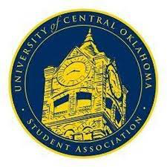
University of Central Oklahoma
Student Association

12th Meeting, Spring Session of the 26th Legislature
Will Rogers
April 24, 2023, 4:00 PM

- Call to Order
(Begins the meeting, includes opening customs and procedures)
- Pledge of Allegiance
- Roll Call
The meeting was called to order by Chairwomen Howry at 4:16 pm.

- Approval of the Minutes
(This approves the secretary’s record keeping of the last meeting)

- Special Orders
(Formalities or Proceedings not according to law or custom)
Lauren Berry expressed how grateful she is of this position and how much this position has benefited her.
Izabel Barry- Introducing positions and spoke about the roles as in committees.

Elections

Chair:
Izabel Barry

Vice Chair:
Jakob Carlson

Secretary:
Cooper Autry

Items to be Considered

CR22-212- Unanimous Consent
CB22-201- Unanimous Consent
CB22-202- Unanimous Consent
- New Business

(New legislation to be sent to committee)

- Student Concerns
(Open forum for any student to address concerns to the UCO Student Congress)

- Announcements
(General Announcements)
UCOSA Awards and Recognition
Tomorrow at 6pm is take back the night and have a march around campus.
Senator Summers- Senator Summers Unity Fest is this Thursday and engagement with the organizations.

- Adjournment
(End of meeting, must be motioned and seconded)
The meeting was adjourned at 6:12pm.

