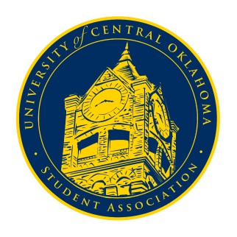
University of Central Oklahoma
Student Association

11th Meeting, Fall Session of the 24th Legislature
Constitution Hall
November 23rd, 2020 4:00 PM

- Call to Order
(Begins the meeting, includes opening customs and procedures)
- Pledge of Allegiance
- Roll Call
The meeting was called to order at 4:22pm by Secretary DeLauren Diaz

- Approval of the Minutes
(This approves the secretary’s record keeping of the last meeting)
- Special Orders
(Formalities or Proceedings not according to law or custom)
The Vote of No Confidence was carried out and yielded the following results:
- Chair De Shannon retained his position with a vote of 5 in the affirmative and 46 in the negative.
- Vice-Chair Hannah Turner retained her position with a vote of 14 in the affirmative and 35 in the negative.
- Secretary DeLauren Diaz retained her position with a vote of 1 in the affirmative and 49 in the negative.

- Items to be Considered
(Business to be seen today)
- CB20-102
An act modifying the process that money distributed from the UCOSA Student Activity Fund Reserve; providing for codification; updating the currently used method of distribution, passed with unanimous consent.
- CFR 20-101
A resolution confirming the appropriation of funds towards the UCO Association of Black Journalists, $750 dollars, passed with unanimous consent.
- CR 20-102
A resolution reaffirming UCO’s position against firearms on campus, passed with unanimous consent.

- New Business
(New legislation to be sent to committee)
- Committee updates

- Student Concerns
(Open forum for any student to address concerns to the UCO Student Congress)
Vice-chair Turner brought up that students have reached out about improving the tutoring program for the college of business as students are currently experiencing long wait times for tutoring sessions and appointments. The topic was delegated to the Academic Affairs committee.

- Announcements
(General Announcements)

- Adjournment
(End of meeting, must be motioned and seconded)
The meeting was adjourned at 5:03pm. The next would be in January 2021.

