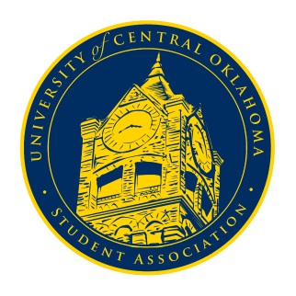
University of Central Oklahoma
Student Association

9th Meeting, Spring Session of the 24th Legislature
Ballroom C
April 5th, 2021 4:00 PM

- Call to Order
(Begins the meeting, includes opening customs and procedures)
- Pledge of Allegiance
- Roll Call
Meeting was called to order at 4:04 pm by Chairman Shannon.

- Approval of the Minutes
(This approves the secretary’s record keeping of the last meeting)

- Special Orders
(Formalities or Proceedings not according to law or custom)
N/A

- Items to be Considered
(Business to be seen today)
- CR20-205
An act of procedure, removing Senators who have failed to meet the requirements for attendance, passed with 40 affirmative votes.
- New Business
(New legislation to be sent to committee)
N/A

- Student Concerns
(Open forum for any student to address concerns to the UCO Student Congress)
N/A

- Announcements
(General Announcements)
Senator Loveless announced that the Student Alliance for Equality would be hosting a game night on Tuesday, April 6th., and the Women’s Research and BGLTQ+ Center is hosting a queer seminar on April 8th. They are also doing free STI testing on April 8th from 10-2.
The Native American Student Association would be having an Easter egg hunt on campus; make sure to tag them on Instagram if you find eggs.
Native American Student Association executive board applications are now open.
The Asian American Student Association’s kickoff for Asian American Heritage Month would be Tuesday, April 6th.

Senator Farias announced that Bronchothon would be having two benefits, one on Tuesday at Fish City from 10:30-7:30 and the other on Thursday at Downtown Nutrition from 7:30 to 3.
He also announced that DRT pushed the deadline for executive board applications to Friday at 5 pm.
Senator Farias asked all senators to wear teal on Tuesday to support the sexual assault victims and survivors.
Vice President Coleman thanked everyone for sharing graduation concerns and helping us advocate for change; he also congratulated everyone on the outcome.
Senator Owens announced Student Body President and Vice President elections would be on Tuesday from 8-5 as well as senator elections. OSGA would be having Spring Congress the coming weekend; let him or an executive member know if you are interested in attending.
Vice Chairwoman Diaz reminded everyone of the importance of senator elections on Tuesday and to vote. The link would be in the GroupMe for us to share.
She reminded us that executive board elections are coming up, and nominations would be on April 12th. You cannot nominate yourself, but you can ask someone to nominate you; you also cannot be nominated for multiple positions. The second part of the process will be on April 19th, our last congressional session of the semester. Candidates will speak for themselves for five minutes and then have ten minutes to answer questions. Someone must speak on your behalf for three minutes. If anyone has questions, please ask. The executive board would love to answer and help with anything we can.
Chairman Shannon reminded everyone to fill out the senator shout-outs for the PR committee. This is an opportunity for UCO students to know who is representing them. He asked everyone to watch GroupMe and get those done in a timely manner.

- Adjournment
(End of meeting, must be motioned and seconded)

