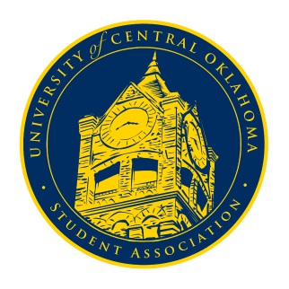
University of Central Oklahoma
Student Association

1st Meeting, Fall Session of the 25th Legislature
Nigh University Center, Will Rogers Room
August 30th, 2021 4:00 PM

- Call to Order
(Begins the meeting, includes opening customs and procedures)
- Pledge of Allegiance
- Roll Call

- Approval of the Minutes
(This approves the secretary’s record keeping of the last meeting)

- Special Orders
(Formalities or Proceedings not according to law or custom)
- State of the Campus: DeLauren Diaz
- Speech: Vice President Chris Lynch
- Swearing in of senators

- Items to be Considered
(Business to be seen today)

- New Business
(New legislation to be sent to committee)

- Student Concerns
(Open forum for any student to address concerns to the UCO Student Congress)

- Announcements
(General Announcements)

- Adjournment
(End of meeting, must be motioned and seconded)

Important Dates:
Sept. 3rd – Final day apply for chair/vice chair positions
Sept. 13th – COVID-19 Town Hall
Sept. 14th – Open forum with Edmond Chief JD Younger from 2-4 pm in Will Rogers
Sept. 20th – UCOSA retreat

