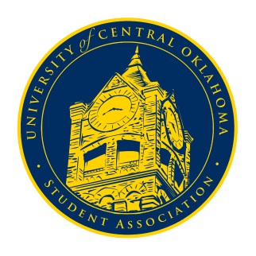
University of Central Oklahoma
Student Association

2nd Meeting, Spring Session of the 24th Legislature
Virtual Meeting via Zoom
February 1st, 2021 4:00 PM

*Due to the end of the Oklahoma Open Meetings Act exception (2020) allowing for online meetings, no formal congressional meeting procedures may take place*

- Begin Meeting
(No formal call to order to roll taking)
Chairman De Shannon began the meeting at 4:02pm. The meeting was recorded and later posted to the UCOSA Facebook.

- Student Concerns
(Open forum for any student to address concerns to the UCO Student Congress)
Senator Farias voiced questions over whether breakfast hours could be extended past the current hour and a half time allotted. Campus Development Chairman Josh Chao stated that he would bring those concerns to housing and dining but that those hours tend to remain inflexible.

- Announcements
(General Announcements)
Vice-Chairwoman Diaz announced that interviews for interim Secretary would take place later in the week. Chairman Shannon announced that new senator applications are open until February 3rd at 5:00pm. Chairman Shannon also announced that the next meeting will be in person in the Nigh in Ballroom C. Quorum must be established in person so he urged everyone to be present if possible.

- Adjournment
(End of meeting, must be motioned and seconded)
The meeting was adjourned at 4:18pm. The next meeting will take place in person on Monday, February 8th, 2021 in Ballroom C of the Nigh University Center.

