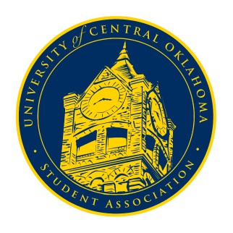
University of Central Oklahoma
Student Association

9th Meeting, Spring Session of the 24th Legislature
Ballroom C
April 5th, 2021 4:00 PM

- Call to Order
(Begins the meeting, includes opening customs and procedures)
- Pledge of Allegiance
- Roll Call

- Approval of the Minutes
(This approves the secretary’s record keeping of the last meeting)

- Special Orders
(Formalities or Proceedings not according to law or custom)

- Items to be Considered
(Business to be seen today)
- CR20-205

- New Business
(New legislation to be sent to committee)

- Student Concerns
(Open forum for any student to address concerns to the UCO Student Congress)

- Announcements
(General Announcements)

- Adjournment
(End of meeting, must be motioned and seconded)

