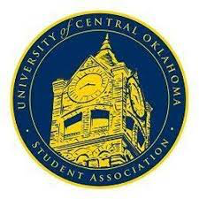
University of Central Oklahoma
Student Association

6th Meeting, Spring Session of the 26th Legislature
Will Rogers
March 20th, 2023, 4:00 PM

- Call to Order
(Begins the meeting, includes opening customs and procedures)
- Pledge of Allegiance
- Roll Call
The meeting was called to order by Chairman Howry at 4:06 pm.

- Approval of the Minutes
(This approves the secretary’s record keeping of the last meeting)
Last week's minutes were approved.

- Special Orders
(Formalities or Proceedings not according to law or custom)

Senator Nobel spoke about the rules and bylaws highlighting this week the specific election rules. Asked Logan Boyd with the election commission and spoke about the constitutional process when it comes to executive elections and then general body election. Spoke about where the voting polls would be located on campus and how everyone can vote online.

- Items to be Considered
CFR22-207-Pass
Yays-31
Nays-0
Ubstains-0
- Old Business
Approval of 7th congressional meeting were approved

- Student Concerns
(Open forum for any student to address concerns to the UCO Student Congress)
Senator Adams spoke about the resident housing having bug problems and how students are voicing their concerns.

- Announcements
(General Announcements)
Senator Adams- Spoke about elections and upcoming events
Senator Smith- Spoke about keeping updated with Oklahoma government and higher education legislation.
Senator Carlson- Encouraging other senators to come participate in ways and means committee.
Senator Boyd- Spoke about the sign up for polling about elections and the process for that.
Lauren Barry- Spoke about Oklahoma senate bill to restrict access to library books (SB397)
Chairman Howry- Spoke about to keep on your calendar important dates coming and asking the exec positions if you are interested if you are interested in running.

Adjournment
(End of meeting, must be motioned and seconded)
The meeting was adjourned at 4:30 pm.

