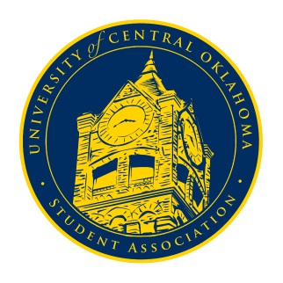
University of Central Oklahoma
Student Association

7th Meeting, Spring Session of the 24th Legislature
Ballroom C
March 22nd, 2021 4:00 PM

- Call to Order
(Begins the meeting, includes opening customs and procedures)
- Pledge of Allegiance
- Roll Call
The meeting was called to order by Chairman Shannon at 4:05 pm.

- Approval of the Minutes
(This approves the secretary’s record keeping of the last meeting)
Minutes were approved.

- Special Orders
(Formalities or Proceedings not according to law or custom)
- MeShawn Green, Inclusive Committee Advocate
Meshawn Green, the Inclusive Committee Advocate, presented a PowerPoint over the Inclusive Committee Response Team; the team is a resource for those of us at UCO to report incidents including hate, prejudice, and bias. The committee has a Core Council made up of different organizational leaders, and they have a spot specifically for a UCOSA member. Get in contact with her for more information. She encouraged us to use the resource and tell others at UCO about it.
- Scott Monetti, Director of Housing and Dining
Chairman of Campus Development Josh Chao arranged for Scott Monetti, Director of Housing and Dining, and Todd Nixon, Senior Director of Retail Dining, to attend Congress and listen to student concerns. Many issues and questions were presented and addressed. Scott and Todd asked us to contact them with any concerns we did not get to talk about. Scott’s email would be sent in the GroupMe.

- Items to be Considered
(Business to be seen today)
- CR20-203
An act of procedure, removing Senators who have failed to meet the requirements for attendance, passed with unanimous consent.
- CR21-02
An act regarding the UCOSA Council Budgets; determining any percentage changes in said budgets; providing budgetary allocations for the next three years, passed with unanimous consent.
- CR21-03
A resolution determining the date for the 2021-2022 University of Central Oklahoma Student Association Congressional Senator Election, passed with unanimous consent.

- New Business
(New legislation to be sent to committee)
N/A

- Student Concerns
(Open forum for any student to address concerns to the UCO Student Congress)
Several concerns were raised about the status of graduation. The issue was sent to the UCOSA Executive Council.
Senator Griffin brought up the issue of multiple handicapped buttons not working on doors around campus, specifically the Thatcher Hall and the CTL doors. Cole would look into those issues.
Senator Harlow brought up some problems that come with having water fountains turned off. The issue was sent to Campus Development, and Cole said he could possibly bring that up in the COVID-19 Response Team meetings.
Senator Farias reminded everyone to be utilizing and spreading awareness of the Counseling and Wellbeing Center resources we have at UCO.
Senator Howry said the PR committee needs senators to be timely and communicate with them, so they can post senators on social media.
Chairman Shannon reminded us to be active in our committees.

- Announcements
(General Announcements)
Senator Owens reminded everyone that filing to be senator next year is open. He also said OSGA would be in April; colleges across the state gather to address different information. Let him or an executive member know if you are interested.
Senator Chavez announced that there would be multiple jazz labs throughout the week free for students.
Chairman Shannon reminded everyone that Congress would be virtual on the 29th.

- Adjournment
(End of meeting, must be motioned and seconded)
The meeting adjourned at 5:17 pm.

