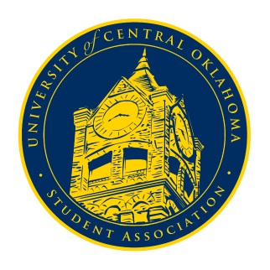
University of Central Oklahoma
Student Association

4th Meeting, Spring Session of the 24th Legislature
Ballroom C
March 1st, 2021 4:00 PM

- Call to Order
(Begins the meeting, includes opening customs and procedures)
- Pledge of Allegiance
- Roll Call
The meeting was called to order at 4:07 pm by Chairman Shannon.

- Approval of the Minutes
(This approves the secretary’s record keeping of the last meeting)
Temporary Secretary Caleb Williams read minutes from March 1st. The minutes were passed.

- Special Orders
(Formalities or Proceedings not according to law or custom)
N/A

- Items to be Considered
(Business to be seen today)
N/A

- New Business
(New legislation to be sent to committee)
N/A

- Student Concerns
(Open forum for any student to address concerns to the UCO Student Congress)
Senator Farias brought up the issue of a student tripping on the manhole covering and asked if it could be resolved.
Cole Stanley asked where the issue happened specifically, and Farias said it happened at the stairs outside the Nigh.
The issue was sent to Campus Development.
Senator Chao brought up possibly inviting Scott Monetti to Congress to air any issues.

- Announcements
(General Announcements)
Senator Loveless announced that any organizations hosting events for women’s history month should reach out to him to be included in the ODI announcements and for us to keep an eye out for GroupMe messages.
Senator Griffin announced that pocketbook monologues would be on Thursday at 7 pm. He also announced that diversity day would be the next Thursday and the resource fair would be from 12-1 pm. We could reach out by the coming Thursday to be registered.
Senator White announced the Public Relations committee needs photos of participation on campus and will begin Senator shout-outs soon.
Vice Chairwoman Diaz asked for everyone who could to stay for the workshop after Congress.
Senator Arvizo announced that Parli Pro will be highly enforced in the coming meetings.
Chairman Shannon said that Senator Arvizo would be the Parliamentarian for the rest of the semester. He shouted out Ways and Means for doing the budget hearing meetings, said student body elections are coming up, the election committee has been decided and will begin work soon, asked Senators to strive to be more active in their committees, and said Leadership Central scholarship applications were due at 11:55 pm that evening.
Senator Howry announced the UCO Women’s Ministry would be hosting more events soon and for us to stay tuned.

- Adjournment
(End of meeting, must be motioned and seconded)
The meeting was adjourned at 4:22 pm until March 8th.

